=========================================================
QUESTION 1 - CREATE TABLE
=========================================================
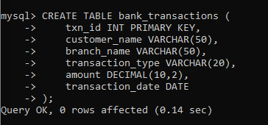
OUTPUT:

Table BANK_TRANSACTIONS created successfully.

=========================================================
QUESTION 2 - ALTER TABLE ADD COLUMN
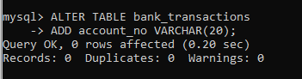

OUTPUT:

Table altered successfully.
=========================================================
QUESTION 3 - ALTER TABLE MODIFY COLUMN
=========================================================
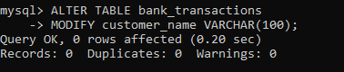
OUTPUT:

Column modified successfully.
=========================================================
QUESTION 4 - RENAME TABLE
=========================================================

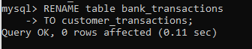
OUTPUT:

Table renamed successfully.
=========================================================
QUESTION 5 - TRUNCATE TABLE
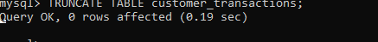
OUTPUT:

All rows deleted.
Table structure remains.
=========================================================
SECTION 2 : DML (DATA MANIPULATION LANGUAGE)
=========================================================
=========================================================
STEP 1 : INSERT SAMPLE DATA

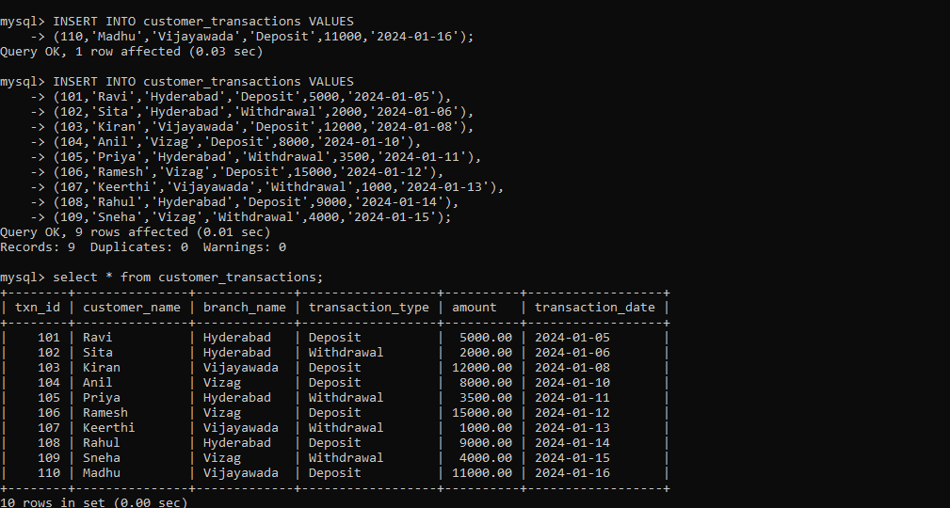
OUTPUT:
1 row inserted.
=========================================================
QUESTION 7 - INSERT
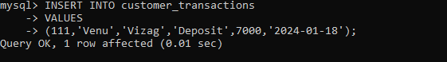
OUTPUT:

1 row inserted.
=========================================================
QUESTION 8 - UPDATE
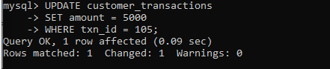
OUTPUT:

1 row updated.
=========================================================
QUESTION 10 - SELECT
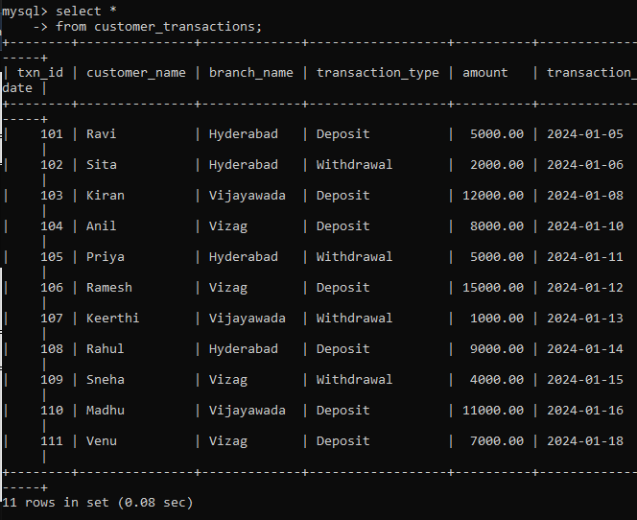
OUTPUT:

10 rows returned.
=========================================================
QUESTION 11 - SELECT WITH WHERE

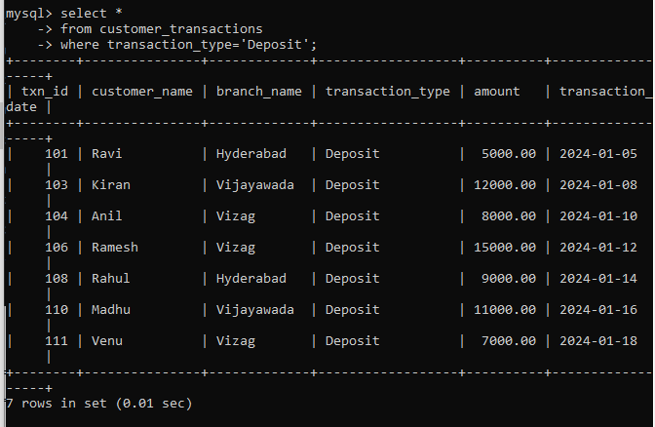OUTPUT:

6 rows returned.\
=========================================================
QUESTION 12 - SELECT WITH ORDER BY
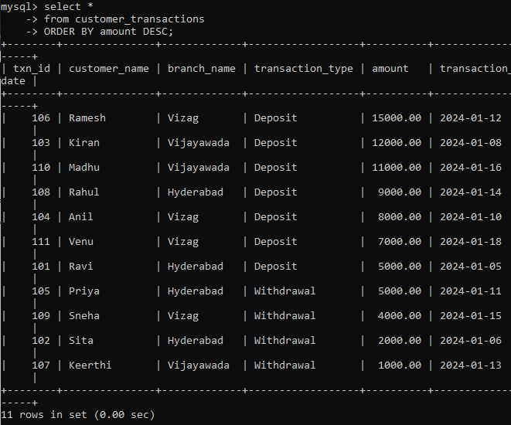
OUTPUT:

Ramesh 15000
Kiran 12000
Madhu 11000
Rahul 9000

=========================================================
SECTION 3 : DCL (DATA CONTROL LANGUAGE)

========================================================
QUESTION 13 - GRANT SELECT

=========================================================
SECTION 4 : TCL (TRANSACTION CONTROL LANGUAGE)
=========================================================
QUESTION 17 - COMMIT

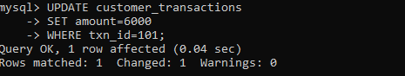
OUTPUT:

Transaction committed successfully.
=========================================================
QUESTION 18 - SAVEPOINT
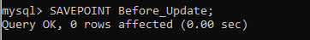
OUTPUT:

Savepoint created.
=========================================================
QUESTION 19 - ROLLBACK TO SAVEPOINT
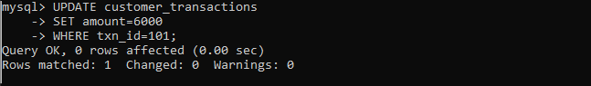
OUTPUT:

Changes rolled back to savepoint.
=========================================================
QUESTION 20 - FULL TCL EXAMPLE

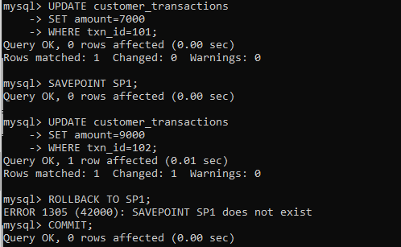
OUTPUT:

Transaction 101 updated and saved.
Transaction 102 restored to previous value.
